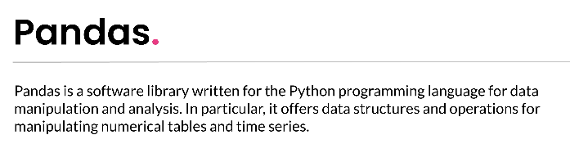
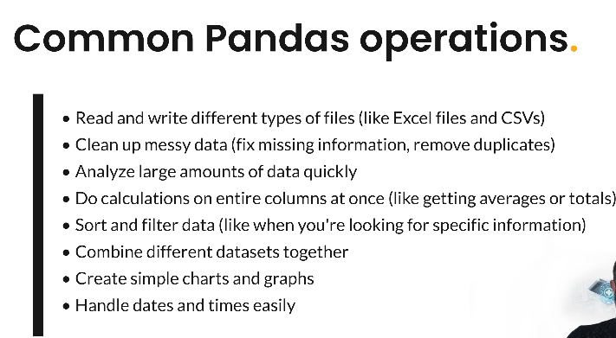
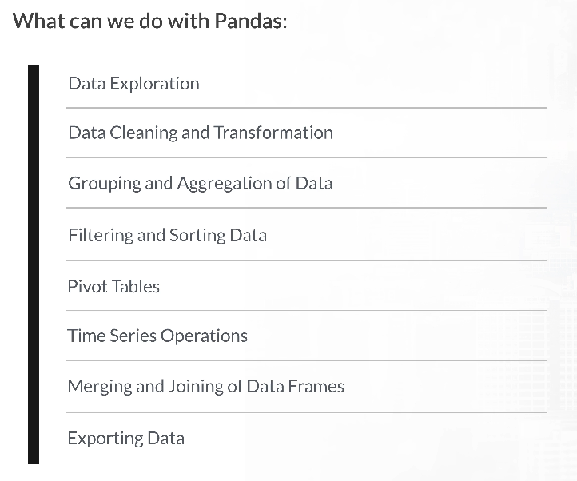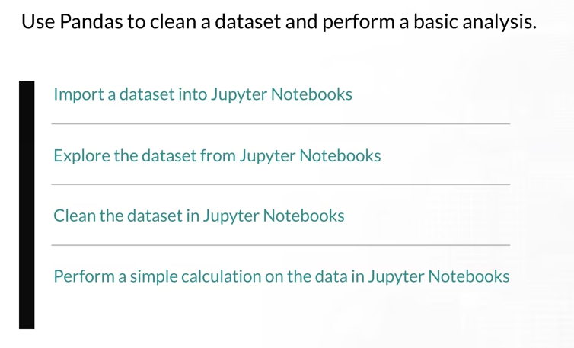
https://pandas.pydata.org/docs/getting_started/index.html
https://pandas.pydata.org/docs/user_guide/index.html

